Practical Mutation Testing at Scale

**Abstract**—Mutation analysis assesses a test suite’s adequacy by measuring its ability to detect small artificial faults, systematically

seeded into the tested program. Mutation analysis is considered one of the strongest test-adequacy criteria. Mutation testing builds on

top of mutation analysis and is a testing technique that uses mutants as test goals to create or improve a test suite. Mutation testing

has long been considered intractable because the sheer number of mutants that can be created represents an insurmountable

problem—both in terms of human and computational effort. This has hindered the adoption of mutation testing as an industry standard.

For example, Google has a codebase of two billion lines of code and more than 150,000,000 tests are executed on a daily basis. The

traditional approach to mutation testing does not scale to such an environment; even existing solutions to speed up mutation analysis

are insufficient to make it computationally feasible at such a scale.

To address these challenges, this paper presents a scalable approach to mutation testing based on the following main ideas:

(1) mutation testing is done incrementally, mutating only changed code during code review, rather than the entire code base;

(2) mutants are filtered, removing mutants that are likely to be irrelevant to developers, and limiting the number of mutants per line and

per code review process; (3) mutants are selected based on the historical performance of mutation operators, further eliminating

irrelevant mutants and improving mutant quality. This paper empirically validates the proposed approach by analyzing its effectiveness

in a code-review-based setting, used by more than 24,000 developers on more than 1,000 projects. The results show that the proposed

approach produces orders of magnitude fewer mutants and that context-based mutant filtering and selection improve mutant quality

and actionability. Overall, the proposed approach represents a mutation testing framework that seamlessly integrates into the software

development workflow and is applicable to industrial settings of any size.

**Index Terms**—mutation testing, code coverage, test efficacy

**1 INTRODUCTION**

Software testing is the predominant technique for ensuring

software quality, and various approaches exist for assessing

test suite efficacy (i.e., a test suite’s ability to detect software

defects). A common approach is code coverage, which is

widely used at Google [1] and measures the degree to which

a test suite exercises a program. Code coverage is intuitive,

cheap to compute, and well supported by commercial-grade

tools. However, code coverage alone is insufficient and

may give a false sense of efficacy, in particular if program

statements are covered but their expected outcome is not asserted

upon [2], [3]. An alternative approach that addresses

this limitation is mutation analysis, which systematically

seeds artificial faults, called mutants, into a program and

measures a test suite’s ability to detect them [4]. Mutation

analysis addresses is widely considered the best approach

for evaluating test suite efficacy [5], [6], [7]. Mutation testing

is an iterative testing approach that builds on top of mutation

analysis and uses undetected mutants as concrete test

goals to guide the testing process.

As a concrete example, consider the following fully

covered, yet weakly tested, function view:

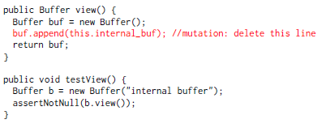

The test exercises the function, but does not assert upon

its effects on the returned buffer. In this case, mutation

analysis outperforms code coverage: even though the line

that appends some content to buf is covered, a developer

is not informed about the fact that no test checks for its

effects. The statement-deletion mutation highlighted in the

code example explicitly points out this testing weakness: the

test does not fail when inserting this artificial defect.

Google always strives to improve test quality, and thus

decided to implement and deploy mutation testing to evaluate

its efficacy. The scale of Google’s code base with approximately

2 billion lines of code, however, rendered the

traditional approach to mutation testing infeasible: more

than 150,000,000 test executions per day are gatekeepers

for 40,000 change submissions to this code base, ensuring

that 14,000 continuous integrations remain healthy on a

daily basis [8], [9]. First, systematically mutating the entire

code base, or even individual projects, creates a substantial

number of mutants, each potentially requiring the execution

of many tests. Second, neither the traditionally computed

mutant-detection ratio, which quantifies test suite efficacy,

nor simply showing all mutants that have evaded detection

to a developer would be actionable. Given that resolving a

single mutant takes several minutes [10], [11], the required

developer effort for resolving all undetected mutants would

be prohibitively expensive, even at a small scale.

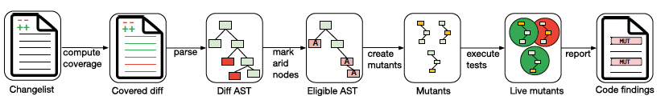

Fig. 1: The Mutation Testing Service. For a given changelist, line coverage is computed and the code is parsed into an AST.

For AST nodes spanning covered lines, arid nodes are marked, using the arid node detection heuristics, and only non-arid

(eligible) nodes are mutated. The generated mutants are tested, and surviving mutants are reported as code findings.

To make matters worse, even when applying sampling

techniques to substantially reduce the number of mutants,

developers at Google initially classified 85% of reported mutants

as unproductive. An unproductive mutant is either trivially

equivalent to the original program or it is detectable,

but adding a test for it would not improve the test suite [11].

For example, mutating the initial capacity of a Java collection

(e.g., new ArrayList(64) 7! new ArrayList(16)) creates

an unproductive mutant. While it is possible to write a test

that asserts on the collection capacity or expected memory

allocations, it is unproductive to do so. In fact, it is conceivable

that these tests, if written and added, would even

have a negative impact because their change-detector nature

(specifically testing the current implementation rather than

the specification) violates testing best practices and causes

brittle tests and false alarms.

Faced with the two major challenges in deploying mutation

testing—the computational costs of mutation analysis

and the fact that most mutants are unproductive—we have

developed a mutation testing approach that is scalable and

usable, based on three central ideas:

1) Our approach performs mutation testing on code changes: it

considers only changed lines of code and reports mutants

during code review (Section 2, based on our prior

work [12]). This greatly reduces the number of lines in

which mutants are created and matches a developer’s

unit of work for which additional tests are desirable.

2) Our approach uses transitive mutant suppression: it uses

heuristics based on developer feedback (Section 3,

based on our prior work [12]). The feedback of more

than 20,000 developers on thousands of mutants over

six years enabled us to develop heuristics for mutant

suppression that reduce the ratio of unproductive mutants

from 85% to 11%.

3) Our approach uses probabilistic, targeted mutant selection:

it reports a restricted number of mutants based on

historical mutant performance, further avoiding unproductive

mutants (Section 4).

Our evaluation of the proposed approach involved 760,000

code changes and 2 million mutants reported during code

review, out of a total of almost 17 million generated mutants

(Section 5). The results show that our approach makes

mutation testing feasible and actionable—even for industryscale

software development environments.

**2 MUTATION TESTING AT GOOGLE**

Mutation testing at Google faces challenges of scale, both

in terms of computation time as well as integration into the

developer workflow. Even though existing work on selective

mutation and other optimizations [13] can substantially

reduce the number of mutants that need to be analyzed,

it remains prohibitively expensive to compute the mutantdetection

ratio for Google’s entire codebase due to its size.

It would be even more expensive to keep re-computing

the mutant-detection ratio, e.g., on a daily or weekly basis,

and it is infeasible to compute it after each commit. In

addition to the costs of computing that ratio, we were unable

to find a good way to report it to the developers in an

actionable way: it is neither concrete nor actionable, and

it does not guide testing. Reporting individual mutants at

scale to developers is also challenging, in particular due to

unproductive mutants.

Addressing the challenges of scale and unproductive

mutants, we designed and implemented a mutation testing

approach that differs from the traditional approach,

described in the literature [14]. For scalability, we designed

and implemented diff-based mutation testing, which only generates

and evaluates mutants for covered, changed lines; for

productivity, we designed and implemented an approach

for mutant suppression and probabilistic mutant selection.

Mutation testing at Google starts when a developer

sends a code change for code review. The mutation testing

process consists of four high-level steps: code coverage analysis

(Section 2.1), mutant generation (Section 2.2), mutation

analysis (Section 2.3), and reporting surviving mutants in

the code review process (Section 2.4).

Figure 1 details the Mutation Testing Service. (1) It starts

with a changelist submitted for code review. (2) Once codecoverage

metadata is available, it determines the set of lines

that are covered, and added or modified in the changelist.

(3) It then constructs an AST of each affected file and visits

each covered node. (4) It then labels arid nodes (nodes

that if mutated create unproductive mutants), based on

the heuristics accumulated using developer feedback about

mutant productivity over the years. Arid node labeling

happens before mutants are generated, and hence mutants

in arid nodes are never generated in the first place. (5)

Mutagenesis then generates mutants for eligible nodes (i.e.,

each node that is not arid and that is covered by at least one

test). (6) The Mutation Testing Service then evaluates the

mutants against the existing tests, and (7) reports a subset

of surviving mutants as code findings in the code review.

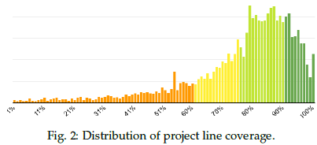

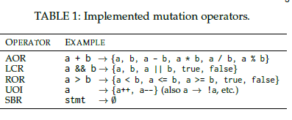

**2.1 Prerequisites: Changelists and Coverage**

A changelist is an atomic update to the version control

system, and it consists of a list of files, the operations to

be performed on these files, and possibly the file contents

to be modified or added, along with metadata like change

description, author, etc.

Once a developer sends a changelist to peer developers

for code review, various static and dynamic analyses are

run for that changelist and findings are reported to the

developer and the reviewers. Line coverage is one such

analysis: during code review, overall and delta code coverage

is reported to the developers [1]. Overall code coverage is

the ratio of the number of lines covered by tests in the

file to the total number of instrumented lines in the file.

The number of instrumented lines is usually smaller than

the total number of lines, since artifacts like comments or

pure whitespace lines are excluded. Delta coverage is the

ratio of number of covered added or modified lines to the

total number of added or modified lines in the changelist.

Figure 2 shows the line-coverage distribution per project,

indicating that line coverage of most projects is satisfactory.

Code coverage is a prerequisite for running mutation

analysis due to the high cost of generating and evaluating

mutants in uncovered lines, all of which would inevitably

survive because the code is not tested. Once line-level coverage

is available for a changelist, mutagenesis is triggered.

Google uses Bazel as its build system [15]. Build targets

explicitly list their sources and dependencies, and correspond

to an arbitrary number of test targets, each of which

can involve multiple tests. Tests are executed in parallel.

Using the explicit dependency and source listing, the codecoverage

analysis provides information about which test

target covers which lines in the source code, thereby linking

lines of code to a set of tests covering them. Line-level

coverage is used to determine the set of tests that need

to be run in an attempt to kill a mutant. This approach is

also implemented in other mutation testing tools, including

PIT [16] and Major [17], [18].

**2.2 Mutagenesis**

The mutagenesis service receives a request to generate point

mutations, i.e., mutations that produce a mutant which differs

from the original in one AST node on the requested

line. For each supported programming language, a special

mutagenesis service capable of navigating the AST of a

compilation unit in that language accepts point mutation

requests and replies with potential mutants. The mutation

operators are implemented as AST visitors, an approach

also taken by other mutation tools (e.g., [19]). For each

point mutation request, i.e., a (file; line) tuple, a mutation

operator is selected and a mutant is generated in that line

if that mutation operator is applicable to it. If no mutant

is generated by the mutation operator, another operator is

selected and so on until either a mutant is generated or all

mutation operators have been tried and no mutant could

be generated. There are two mutation operator selection

strategies, random and targeted, detailed in Section 4.

The Mutation Testing Service generates at most one

mutant per line, for scalability reasons and based on the

insight that the vast majority of mutants for a given line

share the same fate—either all or none of them survive

the analysis [20]. This means that if a mutant generated

for a given line does not survive the mutation analysis, no

additional mutants are generated for that line.

The Mutation Testing Service implements mutagenesis

for 10 programming languages: C++, Java, Go, Python,

TypeScript, JavaScript, Dart, SQL, Common Lisp, and

Kotlin. For each language, the service implements five mutation

operators: AOR (Arithmetic operator replacement),

LCR (Logical connector replacement), ROR (Relational operator

replacement), UOI (Unary operator insertion), and

SBR (Statement block removal). These mutation operators

were originally introduced for Mothra [21], and Table 1

gives an example for each. In Python, unary increment and

decrement are replaced by a binary operator to achieve the

same effect due to the language design. In our experience,

the ABS (Absolute value insertion) mutation operator predominantly

created unproductive mutants, mostly because

it acted on time-and-count related expressions, which are

positive and nonsensical if negated. Therefore, the Mutation

Testing Service does not use the ABS operator. Note that our

observations may not hold in general and may be a function

of the style and features of our codebase.

**2.3 Mutation Analysis**

Once mutagenesis has generated a set of mutants for a

changelist, a temporary state of the version control system is

prepared for each of them, based on the original changelist,

and then tests are executed in parallel for all those states.

This allows for an efficient interaction and caching between

our version control system and build system, and evaluates

mutants in the fastest possible manner.

Once the mutation analysis results are available, the Mutation

Testing Service selects and reports mutants from the

set of surviving mutants. We limit the number of reported

mutants to at most 7 times the number of total files in

a changelist. This ensures that the cognitive overhead of

understanding all reported mutants is not too high, which

might otherwise cause developers to stop using mutation testing. We empirically determined 7 to be an appropriate

trade-off between test efficacy and cognitive load by collecting

data over the years of running the system. Finally,

the service reports selected surviving mutants in the code

review UI to the author and the reviewers. Note that for

consistency, the Mutation Testing Service selects and reports

mutants in the same line(s) as before if an author adds

additional tests or otherwise updates the changelist, which

triggers a re-execution of the service.

**2.4 Reporting Mutants in the Code Review Process**

Most changes to Google’s codebase, except for a limited

number of fully automated changes, are reviewed by developers

before they are merged into the source tree. Potvin

and Levenberg [9] provide a comprehensive overview of

Google’s development ecosystem. Reviewers can leave comments

on the changed code that must be resolved by the author.

A special type of comment generated by an automated

analyzer is known as a finding. Unlike human-generated

comments, findings do not need to be resolved by the author

before submission, unless a human reviewer marks them as

mandatory. Many analyzers are run automatically when a

changelist is sent for review: linters, formatters, static code

and build dependency analyzers, etc. The majority of analyzers

are based on the Tricorder code analysis platform [22].

The Mutation Testing Service reports selected mutants

to developers during the code review process, which maximizes

the chances that these will be considered by the developers.

The number of comments displayed during code

review can be large, so it is important that all tools produce

actionable findings that can be used immediately by the

developers. Reporting non-actionable findings during code

review has a negative impact on the author and the reviewers.

If a finding (e.g., a surviving mutant) is not perceived

as useful, developers can report that with a single click on

the finding. If any of the reviewers consider a finding to be

important, they can indicate that to the changelist author

with a single click. Figure 3 shows an example mutant

displayed in Critique, Google’s Code Review system [23],

including the “Please Fix” and “Not useful” links in the

bottom corners. This feedback is accessible to the owner of

the system that created the findings, so quality metrics can

be tracked, and non-actionable findings triaged and ideally

prevented in the future.

To be of any use to the author and the reviewers, code

findings need to be actionable and reported quickly, before

the review is complete. To that end, the Mutation Testing

Service performs mutant suppression (Section 3), and it

probabilistically selects mutants based on their historical

mutation operator performance (Section 4).

**3 SUPPRESSING UNPRODUCTIVE MUTANTS**

Some parts of the code are less interesting than others.

Reporting live mutants in uninteresting statements (e.g.,

logging statements for debugging purposes) has a negative

impact on cognitive load and time spent analyzing mutants.

Because developers do not perceive adding tests to kill

mutants in uninteresting code as improving the overall

efficacy of the test suite, such mutants tend to survive and

be flagged as unproductive.

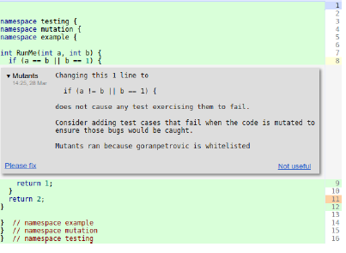

Fig. 3: Mutant reported in the code review tool.

This section proposes an approach for suppressing unproductive

mutants, based on a set of heuristics for detecting

arid (i.e., uninteresting) AST nodes. There is a trade-off

between correctness and usability of the results; a heuristic

may prevent a mutation in very few non-arid nodes as a

side-effect of suppressing mutations in many arid nodes.

We argue that this is a good trade-off because the number

of possible mutants is orders of magnitude larger than

what the mutation service could reasonably report to the

developers within the existing developer tools. Moreover,

preventing non-actionable findings is more important than

reporting all actionable findings.

**3.1 Detecting Arid Nodes**

In order to prevent the generation of unproductive mutants,

the Mutation Testing Service identifies arid nodes

in the AST, which are related to uninteresting statements.

Examples of arid nodes include calls to memory-reserving

functions like std::vector::reserve and writing to stdout;

these are typically not tested by unit tests.

Mutation operators create mutants based on the AST of

a program. The AST contains nodes, which are statements,

expressions or declarations, and their child-parent relationships

reflect their connections in the source code [24]. Most

compilers differentiate between simple and compound AST

nodes. Simple nodes have no body; for example, a functioncall

expression provides a function name and arguments,

but has no body. Compound nodes have at least one body;

for example, a for loop might have one body, while an if

statement might have two—the then and else branches.

Our heuristics-based approach for labeling nodes as arid

is two-fold:

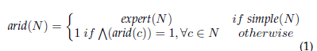

Here, N 2 T is a node in the abstract syntax tree T of a

program, simple is a boolean function determining whether a

node is a simple or compound node (compound nodes contain

their children nodes c), and expert is a partial boolean

function mapping a subset of simple nodes in T to the property of being arid. The first part of Equation 1 operates

on simple nodes, using the expert function, which encodes

knowledge that is manually curated for each programming

language and adjusted over time. The second part operates

on compound nodes and is defined recursively. A compound

node is arid iff all of its children nodes are arid.

The expert function flags simple nodes as arid and is

based on developer feedback on reported “Not useful”

mutants. This is a manual process: if we determine that a

certain mutant is indeed unproductive and that an entire

class of such mutants should not be created, a rule is added

to the expert function. This is a key component of the

Mutation Testing Service —without it, users would become

frustrated with non-actionable findings and opt out of the

system altogether. Targeted mutation and careful reporting

of mutants have been crucial for the adoption of mutation

testing at Google. So far, we have accumulated more than

one hundred rules for arid node detection.

**3.2 Expert Heuristic Categories**

The expert function consists of various rules, some of which

are mutation-operator-specific, and some of which are universal.

We distinguish between heuristics that prevent the

generation of uncompilable vs. compilable yet unproductive

mutants. Most heuristics deal with the latter category, but

the former is also important, especially in Go, where the

compiler is very sensitive to mutations (e.g., an unused

import is a compiler error). For compilable mutants, we

further distinguish between heuristics for equivalent mutants,

killable mutants, and redundant mutants, as reported

in Table 2.

Each of the four heuristic categories contains one or

more distinct groups of rules, which in turn contain one

or more related rules. For example, all rules that suppress

mutants in logging statements (multiple rules for multiple

types of logging statements and functions) form a distinct

group because they all apply to logging, and the entire

group aims to prevent unproductive killable mutants. The

frequency indicates how often a category is applicable to a

given changelist. For a detailed list of rules, please refer to

the supplementary materials, which can be found online at

<production staff will insert link>.

3.2.1 Heuristics to Prevent Uncompilable Mutants

A mutant should be a syntactically valid program—

otherwise, it would be detected by the compiler and would

not add any value for testing. There are certain mutations,

especially the ones that delete code, that violate this validity

principle. A prime example is deleting code in Go; any

unused variable or imported module produces a compiler

error. The proposed heuristic gathers all used symbols and

puts them in a container instead of deleting them so they

remain referenced and the compiler is appeased.

3.2.2 Heuristics to Prevent Equivalent Mutants

Equivalent mutants, which are semantically equivalent to

the mutated program, are a plague in mutation testing

and cannot generally be detected automatically. However,

there are some groups of equivalent mutants that can be

accurately detected. For example, in Java, the specification

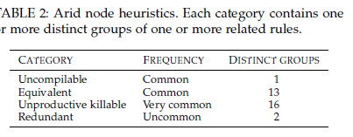

for the size method of a java.util.Collection is that it

returns a non-negative value. This means that mutations

such as collection.size() == 0 7! collection.size() <= 0

are guaranteed to produce an equivalent mutant.

Another example for this category is related to memoization.

Memoization is often used to speed up execution, but

its removal inevitably causes the generation of equivalent

mutants. The following heuristic is used to detect memoization:

an if statement is a cache lookup if it is of the form if

a, ok := x[v]; ok return a, i.e., if a lookup in the map

finds an element, the if block returns that element (among

other values, e.g., Error in Go). Such an if statement is a

cache lookup statement and is considered arid by the expert

function, as is its full body. The following example shows a

cache lookup in Go:

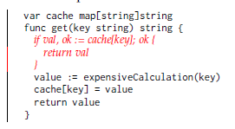

Removing the if statement just removes caching, but does

not change functional behavior, and hence yields an equivalent

mutant. The program still produces the same output

for the same input—albeit slower. Functional tests are not

expected to detect such changes.

As a third example, a heuristic in this category avoids

mutations of time specifications because unit tests rarely test

for time, and if they do, they tend to use fake clocks. Statements

invoking sleep-like functionality, setting deadlines, or

waiting for services to become ready (like gRPC [25] server’s

Wait function that is always invoked in RPC servers, which

are abundant in Google’s code base) are considered arid by

the expert function.

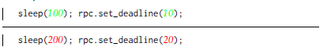

3.2.3 Heuristics to Prevent Unproductive Killable Mutants

Not all code is equally important: some code may result in

killable mutants but the tests that kill them are not valuable

and would not be written by experienced developers; such

mutants are bad test goals. Examples of this category are

increments of values in monitoring system frameworks, low

level APIs or flag changes: these are easy to mutate, easy to

test for, and yet mostly undesirable test goals.

A common way to implement heuristics in this category

is to match function names; indeed we suppress mutants in

calls to hundreds of functions, which is responsible for the largest proportion of suppressions by the expert function.

The prime example of this category is a heuristic that marks

any function call arid if the function name starts with the

prefix log or the object on which the function is invoked is

called logger. We validated this heuristic by randomly sampling

100 nodes that were marked arid by the log heuristic,

and found that 99 indeed were correctly marked, while one

had marginal utility. In total, we have accumulated fuzzy

name suppression rules for more than 200 function families.

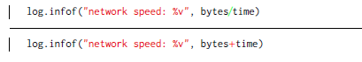

3.2.4 Heuristics to Prevent Redundant Mutants

Recall that the Mutation Testing Service generates at most

one mutant per line and reports a restricted subset of

surviving mutants during code review. Heuristics in this

category suppress some mutants that are redundant (i.e.,

functionally equivalent to other mutants) for two reasons.

First, while redundant mutants are functionally equivalent

to one another, some of them are easier to reason about

than others, rendering them as more productive. Second,

when a developer updates their changelist, possibly writing

tests to kill mutants, that change creates a new snapshot

and triggers a rerun of the mutation service, thereby testing

the change and possibly reporting new mutants. In order

to improve developer productivity and user experience, the

Mutation Testing Service should consistently generate the

same mutant out of a pool of equally productive ones and

avoid divergence from previously reported mutants, in particular

for unchanged lines between snapshots. Such divergence

would cause confusion, introduce cognitive overhead,

and hence lower developer productivity.

As an example, in C++, the LCR mutation operator has a

special case when dealing with NULL (i.e., nullptr), because

of its logical equivalence with false:

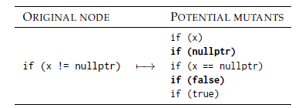

The mutants marked in bold are redundant because the

value of nullptr is equivalent to false. Likewise, the opposite

example, where the condition is if (nullptr == x),

yields redundant mutants for the left-hand side.

3.2.5 Experience with Heuristics

In our experience of applying heuristics, the highest productivity

gains resulted from three heuristics implemented

in the early days: suppression of mutations in logging

statements, time-related operations (e.g., setting deadlines,

timeouts, exponential backoff specifications etc.), and finally

configuration flags. Most of the early feedback was about

unproductive mutants in such code, which is ubiquitous in

the code base. While it is hard to measure exactly, there

is strong indication that these suppressions account for

improvements in productivity from about 15% to 80%. Additional

heuristics and refinements progressivley improved

producitvity to 89%.

Heuristics are implemented by matching AST nodes

with the full compiler information available to the mutation

operator. Some heuristics are unsound: they employ

fuzzy name matching and recognize AST shapes, but may

suppress productive mutants. On the other hand, some

heuristics make use of the full type information (like matching

java.util.HashMap::size calls) and are sound. Sound

heuristics are demonstrably correct, but we have had much

more important improvements of perceived mutant usefulness

from unsound heuristics.

**4 MUTATION OPERATOR SELECTION STRATEGIES**

After labeling arid nodes in the AST, the Mutation Testing

Service generates mutants for the remaining, non-arid

nodes. This involves two challenges. First, only generated

mutants that survive the tests are reported to developers

during code review; mutants that don’t survive just use

computational resources. Given that many mutants don’t

survive the tests and mutagenesis only generates a single

mutant per line, the goal is to create mutants that have a

high chance of survival. An iterative approach, where after

the first round of tests further rounds of mutagenesis could

be run for lines in which mutants were killed, would use the

build and test systems inefficiently, and would take much

longer because of multiple rounds. Similarly, generating all

mutants per line is computationally too expensive. Second,

not all surviving mutants are equally productive: depending

on the context, certain mutation operators may produce

better mutants than others. Therefore, the goal is to create

surviving mutants that have a high chance of being productive.

An effective mutation operator selection strategy not

only constitutes a good trade-off between productivity and

costs, but is also crucial for making mutation analysis results

actionable during code review.

This section presents a basic random selection strategy

that generates one mutant per covered line, considering

information about arid nodes, and a targeted selection strategy,

which additionally considers the past performance of

mutation operators in similar context (Figure 4).

**4.1 Random Selection**

A basic random line-based mutant selection approach could,

for each line in a changelist, select one of the mutants

that can be generated for that line uniformly at random.

Alternatively, such an approach could randomly select a

mutation point in that line first and then randomly select

an applicable mutation operator.

Recall that our approach to mutation testing is based

on the identification of arid nodes, which should not be

mutated at all. Furthermore, our approach generates at most

a single mutant per line; no additional mutants are ever generated.

Listing 1 describes our random selection algorithm

that accounts for these two design decisions. The mutation

operators available for a given language are randomly shuffled

and tried one by one, for each covered, changed line

corresponding to non-arid nodes in the changelist, until a

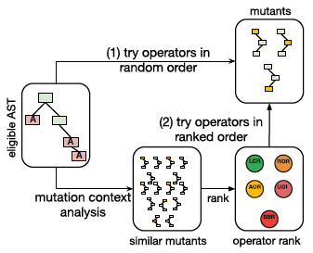

Fig. 4: Random (1) vs. Targeted (2) mutation selection.

mutant is generated for that line or all operators have been

tried. If multiple mutants can be generated in a line, only

one mutant is generated, but which one depends on the

random shuffle and the AST itself. For example, the ROR

mutation operator cannot generate a mutant in a line that

has no relational operators, but the SBR operator might—

most lines can be deleted.

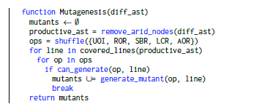

Listing 1: Random selection with suppression.

**4.2 Targeted Selection**

In contrast to the random selection, the targeted selection

strategy ranks the mutation operators by their historical productivity

considering the AST context, as shown in Listing 2.

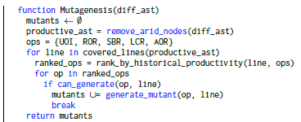

Listing 2: Targeted selection with suppression.

The mutation operator ranking for a given AST node is

based on historical information, in particular survivability

and productivity. A mutation operator’s survivability is the

ratio of surviving mutants generated by that operator in

a given context. A mutation operator’s productivity is the

ratio of productive mutants generated by that operator in a

given context. Productivity is based on developer feedback:

during code review authors and reviewers can flag mutants

shown in a changelist as productive or unproductive. As

these developers understand the context of the mutants they

are flagging, unlike participants performing a labeling task

in a study, we consider this information a strong signal.

For each mutant, the AST context, which describes the

environment of the AST node that was mutated, is stored

along with the productivity feedback and whether the mutant

was killed or not. The targeted selection strategy uses

this information to identify AST nodes that are similar to

the mutated one, based on the AST context. The historical

information of the mutants generated for these similar AST

nodes is then used to rank the mutation operators, rather

than using a random order. Mutagenesis is then attempted

in the resulting order to maximize the probability that the

mutant will survive and will be productive.

**4.3 Mutation Context**

In order to apply historical information about survivability

and productivity, we need to decide how similar candidate

mutations are compared to past mutations. We define a

mutation to be similar if it happened in a similar context,

e.g., replacing a relational operator within an if condition

that is the first statement in the body of a for loop, as shown

in Listing.

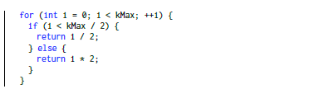

Listing 3: C++ snippet: an if statement within a for loop.

To efficiently capture the similarity of the context of

two mutations, we use the hashing framework for treestructured

data introduced by Tatikonda et al. [26], which

maps an unordered tree into a multiset of simple structures

referred to as pivots. Each pivot captures information

about the relationship among the nodes of the tree (see

Section 4.4).

Finding similar mutation contexts is then reduced to

finding similar pivot multisets. To identify similar pivot

multisets, we produce a MinHash [27] inspired fingerprint

of the pivot multiset. Because the distance in the fingerprint

space correlates with the distance in the tree space, we can

find similar mutation contexts efficiently by finding similar

fingerprints of nodes under mutation.

**4.4 Generating Pivots from ASTs**

In order to capture the intricate relationship between nodes

in the AST, we translate the AST into a multiset of pivots. A

pivot is a triplet of nodes from the AST that encodes their

relationship; for nodes u and v, a pivot p is tuple (lca; u; v),

where lca is the lowest common ancestor of nodes u and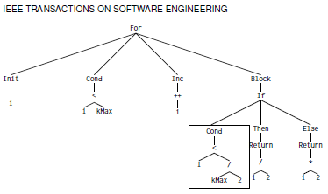

Fig. 5: AST for the C++ example in Listing 3.

*v.* The pivot represents a subtree of the AST. The set of

all pivots involving a particular node describes the tree

from the point of view of that node. In mutation testing,

we are only interested in nodes that are close to the node

being mutated, so we constrain the set of pivots to pivots

containing nodes that are a certain distance from the node

considered for mutation.

In the example of replacing a relational operator in an

if condition within a body of the for loop in Listing 3, one

pivot might be (if, Cond, _), and another (Cond, i, kMax). All

combinations of two nodes within some distance from the

node being mutated in the AST in Figure 5 and their lowest

common ancestor make pivot structures.

Pivot multisets P precisely preserve the structural relationship

of the tree nodes (parent-child and ancestor relations),

so the tree similarity of two AST subtrees T1 and

T2 can be measured as the Jaccard index of the pivot

multisets [26] as shown in equation 2.

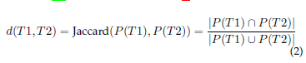

**4.5 Fingerprinting Pivot Multisets**

Pivot multisets are potentially quadratic in tree size, leading

to costly union and intersection operations. Even a trivial

if statement with a single return statement produces large

pivot sets, and set operations become prohibitive. To alleviate

that, a fingerprinting function is applied to convert large

pivot multisets into fixed-sized fingerprints.

We hash the pivot sets to single objects that form the

multiset of representatives for the input AST. The size of the

multiset can be large, especially for large programs. In order

to improve the efficiency of further manipulation, we use a

signature function that converts large pivot hash sets into

shorter signatures. The signatures are later used to compute

the similarity between the trees, taking into consideration

only the AST node type and ignoring everything else, like

type data or names of the identifiers.

We use a simple hash function to hash a single pivot *p =*

*(lca; u; v)* into a fixed-size value, proposed by Tatikonda and

Parthasarathy [26].



For a; b; c we pick small primes, and for K a large prime

that fits in 32 bits. To be able to hash AST nodes, we assign

sparse integer hash values to different AST node types in

each language, e.g., a C++ FunctionDecl is assigned 8500,

and CXXMethodDecl 8600. For nodes in the pivot (lca; u; v)

we use these assigned hashes.

For example, given a = 17, b = 59, c = 83 and K =

15485863, we can calculate the hash of the pivot (if, <, _),

as simply as



with 32800 and 22400 being the integer hash values

assigned to IfStmt and BinaryOperator C++ AST nodes.

The signature for such a bag of representatives is generated

using a MinHashing technique. The set of pivots is

permuted and hashed under that permutation. To minimize

the false positives and negatives (i.e., different trees hash

to similar hashes, or vice versa), this is repeated k times,

resulting in k-MinHashes.

The goal is that the signatures are similar for similar

(multi)sets and dissimilar for dissimilar ones. Jaccard similarity

between two sets can be estimated by comparing

their MinHash signatures in the same way [27], as shown

in equation 3. The MinHash scheme can be considered an

instance of locality-sensitive hashing, in which ASTs that

have a small distance to each other are transformed into

hashes that preserve that property.

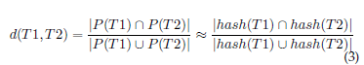

When mutating a node, we calculate its pivot set and

hash it.We find similar AST contexts using nearest neighbor

search algorithms. We observe how different mutants behave

in this context and which mutation operators produce

the most productive and surviving mutants. This is the basis

for targeted mutation selection.

**5 EVALUATION**

In order to bring value to developers, the Mutation Testing

Service at Google needs to report few productive mutants,

selected from a large pool of mutants—most of which

are unproductive. Recall that a productive mutant elicits

an effective test, or otherwise advances code quality [11].

Therefore, our goal is two-fold. First, we aim to select mutants

with a high survival rate and productivity to maximize

their utility as test objectives. Second, we aim to report

very few mutants to reduce computational effort and avoid

overwhelming developers with too many findings.

Since applying mutation testing on the entire code base

is simply infeasible, we focus on diff-based mutation in our

evaluation. In addition to the basic design decision of applying

mutation testing at the level of changelists, two technical

solutions reduce the number of mutants: (1) mutant

suppression using arid nodes and (2) one-per-line mutant

selection. Our evaluation uses two datasets (Section 5.1) and

answers four research questions. The first research question

concerns the effectiveness of our two technical solutions:

TABLE 3: Summary of the mutant dataset. (Note that SQL,

Common Lisp, and Kotlin are excluded from our analyses

because of insufficient data.)

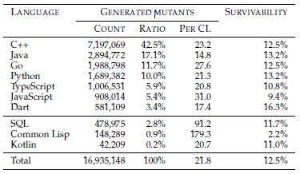

_ **RQ1 Mutant suppression**. How effective is mutant

suppression using arid nodes and 1-per-line mutant

selection? (Section 5.2)

To understand the influence of mutation operator selection

on mutant survivability and productivity in the remaining

non-arid nodes, we consider historical data, including

developer feedback. We aim to answer the following two

research questions:

_ **RQ2 Mutant survivability**. Does mutation operator

selection influence the probability that a generated mutant

survives the test suite? (Section 5.3)

_ **RQ3 Mutant productivity**. Does mutation operator

selection influence developer feedback on a generated

mutant? (Section 5.4)

Having established the influence of individual mutation operators

on survivability and productivity, the final question

is whether mutation context can be used to improve both.

Therefore, our final research question is as follows:

_ **RQ4 Mutation context**. Does context-based selection of

mutation operators improve mutant survivability and

productivity? (Section 5.5)

**5.1 Experiment Setup**

For our analyses, we established two datasets, one with

data on all mutants, and one containing additional data on

mutation context for a subset of all mutants.

**Mutant dataset.** The mutant dataset contains 16,935,148

mutants across 10 programming languages: C++, Java, Go,

Python, TypeScript, JavaScript, Dart, SQL, Common Lisp,

and Kotlin. Table 3 summarizes the mutant dataset and

gives the number and ratio of mutants per programming

language, the average number of mutants per changelist

and the percentage of mutants that survive the test suite.

Table 4 breaks down the numbers by mutation operator.

We created this dataset by gathering data on all mutants

that the Mutation Testing Service generated since its

inauguration, which refers to the date when we made the

service broadly available, after the initial development of the

service and its suppression rules (see Section 3.2.5). We did

not perform any data filtering, hence the dataset provides

information about all mutation analyses that were run.

In total, our data collection considered 776,740 changelists

that were part of the code review process. For these,

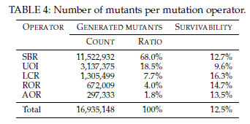

16,935,148 mutants were generated, out of which 2,110,489

were reported. Out of all reported mutants, 66,798 received

explicit developer feedback. For each considered changelist,

the mutant dataset contains information about:

_ affected files and affected lines,

_ test targets testing those affected lines,

_ mutants generated for each of the affected lines,

_ test results for the file at the mutated line, and

_ mutation operator and context for each mutant.

Our analysis aims to study the efficacy and perceived

productivity of mutants and mutation operators across programming

languages. Note that our mutant dataset is likely

specific to Google’s code style and review practices. However,

the code style is widely adopted [28], and the modern

code review process is used throughout the industry [29].

Information about mutant survivability per programming

language or mutation operator can be directly extracted

from the dataset and allows us to answer research

questions **RQ1**, **RQ2** and **RQ3**.

**Context dataset.** The context dataset contains 4,068,241

mutants (a subset of the mutant dataset) for the top-four

programming languages: C++, Java, Go, and Python. Each

mutant in this dataset is enriched with the information of

whether our context-based selection strategy would have

selected that mutant. When generating mutants, we would

also run the context-based prediction, and we persisted

the prediction information along with the mutants. If the

randomly chosen operator was indeed what the prediction

service picked, this mutant is the one with the highest

predicted value. For each mutant, the dataset contains:

_ all information from the mutant dataset,

_ predicted survivability and productivity for each mutation

in similar context, and

_ information about whether the mutant has the highest

predicted survivability/productivity.

We created this dataset by using our context-based mutation

selection strategy during mutagenesis on all mutants

during a limited period of time. During this time, we

automatically annotated the mutants, indicating whether

a mutant would be picked by the context-based mutation

selection strategy along with the mutant outcome in terms

of survivability and productivity. This dataset enables the

evaluation of our context-based mutation selection strategy

and allows us to answer research question **RQ4**.

**Experiment measures:** Surviving the initial test suite is a

precondition for surfacing a mutant, but survivability alone

is not a good measure of mutant productivity. Developer

feedback indicating that a mutant is indeed (un)productive

is a stronger signal.

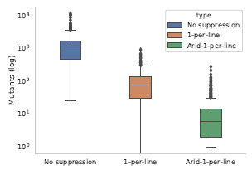

Fig. 6: Number of generated mutants per changelist for no

suppression (traditional mutagenesis), 1-per-line and arid-1-

per-line (our approach). (Note the log-scaled vertical axis.)

We measure mutant productivity via user feedback gathered

from Critique (Section 2.4), where each reported mutant

displays a Please fix (productive mutant) and a Not

useful (unproductive mutant) link. Please fix corresponds to

a request to the author of a changelist to improve the test

suite based on the reported mutant; not useful corresponds

to a false alarm or generally a non-actionable code finding.

82% of all reported mutants with feedback were labeled

as productive by developers. Note that this ratio is an

aggregate over the entire data set. Since the inauguration

of the Mutation Testing Service, productivity has increased

over time from 80% to 89% because we generalized the

feedback on unproductive mutants and created suppression

rules for the expert function, described in Section 3. This

means that later mutations of nodes in which mutants were

found to be unproductive will be suppressed, generating

fewer unproductive mutants over time. Reported mutants

without explicit developer feedback are not considered for

the productivity analysis.

**5.2 RQ1 Mutant Suppression**

In order to compare our mutant-suppression approach

with the traditional mutagenesis, we (1) randomly sampled

5,000 changelists from the mutant dataset, (2) determined

how many mutants traditional mutagenesis produces, and

(3) compared the result with the number of mutants generated

by our approach. (Since traditional mutation analysis is

prohibitively expensive at scale, we adapted our system to

only generate all mutants for the selected changelists.) Figure

6 shows the results for three strategies: no suppression

(traditional), select one mutant per line, and select one mutant

per line after excluding arid nodes (our approach). We

include the 1-per-line approach in the analysis to evaluate

the individual contribution of the arid-node suppression,

beyond sampling one mutant per line.

As shown in Table 5, the median number of generated

mutants is 820 for traditional mutagenesis, 77 for 1-per-line

selection, and only 7 for arid-1-per-line selection. Hence,

our mutant-suppression approach reduces the number of

mutants by two orders of magnitude. Table 5 also shows the

results for a Mann-Whitney U test, which confirms that the

distributions are statistically significantly different.

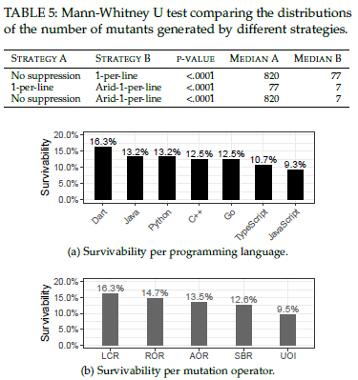

Fig. 7: Mutant survivability.

Our mutant-suppression approach generates fewer than

20 mutants for most changelists; the 25th and 75th percentiles

are 3 and 19, respectively. In contrast, the 25th

and 75th percentiles for 1-per-line are 31 and 138 mutants.

Traditional mutagenesis generates more than 450 mutants

for most changelists (the 25th and 75th percentiles are 460

and 1734, respectively), further underscoring that this approach

is impractical, even at the changelist level. Presenting

hundreds of mutants, most of which are not actionable, to

a developer would almost certainly result in that developer

abandoning mutation testing altogether.

**RQ1:** Arid-node suppression and 1-per-line selection significantly

reduce the number of mutants per changelist, with a

median of only 7 mutants per changelist (compared to 820

mutants for traditional mutagenesis).

**5.3 RQ2 Mutant Survivability**

Mutant survivability is important because we generate at

most a single mutant per line—if that mutant is killed, no

other mutant is generated. To be actionable, mutants have to

be reported as soon as possible in the code review process,

as described in Section 4. Therefore, we aim to maximize

mutant survivability because it directly impacts the number

of reported mutants.

Overall, 87.5% of all generated mutants are killed by

the initial test suite. Note that this is not the same as

the traditional mutation score [30] (ratio of killed mutants

to the total number of mutants) because mutagenesis is

probabilistic and only generates a subset of all mutants. This

means only a fraction of all possible mutants are generated

and evaluated, and many other mutants are never generated

because they are associated with arid nodes.

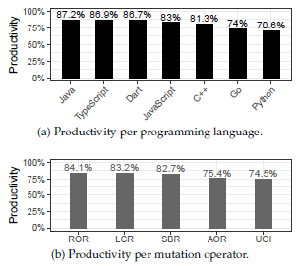

Fig. 8: Mutant productivity.

Tables 3 and 4 show the distribution of number of mutants

and mutant survivability, broken down by programming

language and mutation operator. Figure 7 visualizes

the mutant survivability data. Because the SBR mutation

operator can be applied to almost any non-arid node in the

code, it is no surprise that this mutation operator dominates

the number of mutants, contributing roughly 68% of all

mutants. While SBR is a prolific and versatile mutation operator,

it is also the second least likely to survive the test suite:

when applicable to a changelist, SBR mutants are reported

during code review with a probability of 12.6%. Overall,

mutant survivability is similar across mutation operators,

with a notable exception of UOI, which has a survivability

of only 9.5%. Mutant survivability is also similar across

programming languages with the exception of Dart, whose

mutant survivability is noticeably higher.We conjecture that

this is because Dart is mostly used for web development

which has its own testing challenges.

**RQ2:** Different mutation operators result in different mutant

survivability; for example, the survival rate of LCR is almost

twice as high as that of UOI.

**5.4 RQ3 Mutant Productivity**

Mutant productivity is the most important measure, because

it directly measures the utility of a reported mutant. Since

we only generate a single mutant in a line, that mutant

ideally should not just survive the test suite but also be

productive, allowing developers to improve the test suite

or the source code itself. Given Google’s high accuracy

and actionability requirements for surfacing code findings

during code reviews, we rely on developer feedback as the

best available measure for mutant productivity. Specifically,

we consider a mutant a developer marked with Please fix

to be more productive than others. Likewise, we consider a

mutant a developer marked with Not useful to be less productive

than others. We compare the mutant productivity

across mutation operators and programming languages.

Figure 8 shows the results, indicating that mutant productivity

is similar across mutation operators, with AOR

and UOI mutants being noticeably less productive. For

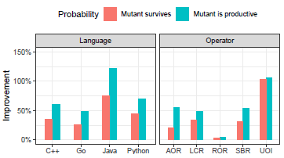

Fig. 9: Improvements achieved by context-based selection.

(0% improvement corresponds to random selection.)

example, ROR mutants are productive 84.1% of the time,

whereas, UOI mutants are only productive 74.5% of the

time. The differences between programming languages are

even more pronounced, with Java mutants being productive

87.2% of the time, compared to Python mutants that are

productive 70.6% of the time. This could be due to code

conventions, language common usecase scenarios, testing

frameworks or simply the lack of heuristics. We have found

that Python code generally requires more tests because of

the lack of the compiler. Unlike Python which is mostly used

for backends, JavaScript, TypeScript and Dart are predominantly

used in frontend code that is radically different.

**RQ3:** ROR, LCR, and SBR mutants show similar productivity,

whereas AOR and UOI mutants show noticeably lower productivity.

**5.5 RQ4 Mutation Context**

We examine whether context-based selection of mutation

operators improves mutant survivability and productivity.

Specifically, we determine whether context-based selection

of mutation operators increases the probability of a generated

mutant to survive and to result in a Please fix request,

when compared to the random-selection baseline.

Figure 9 shows that selecting mutation operators based

on the AST context of the node under mutation substantially

increases the probability of the generated mutant to survive

and to result in a Please fix request. While improvements

vary across programming languages and across mutation

operators, the context-based selection consistently outperforms

random selection. The largest productivity improvements

are achieved for UOI, AOR, and SBR, which generate

most of all mutants. Intuitively, these improvements mean

that context-based selection results in twice as many productive

UOI mutants (out of all generated mutants), when

compared to random selection. Figure 9 also shows to what

extent these improvements can be attributed to the fact that

simply more mutants survive. Since the improvements for

productivity increase even more than those for survivability,

context-based selection not only results in more reported

mutants but also in higher productivity of these mutants.

Overall, the survival rate increases by over 40% and the

probability that a reviewer asks for a generated mutant to

be fixed increases by almost 50%.

It is important to put these improvements into context.

Probabilistic diff-based mutation analysis aggressively trims

down the number of considered mutants from thousands in

a representative file to a mere few, and enables mutants to be

effectively presented to developers as potential test targets.

The random-selection approach produces fewer surviving

mutants of lower productivity.

**RQ4:** Context-based selection improves the probability that a

generated mutant survives by more than 40% and the probability

that a generated mutant is productive by almost 50%.

**6 RELATED WORK**

There are several veins of research that are related to this

work. Just et al. proposed an AST-based program context

model for predicting mutant effectiveness [31]. Fernandez

et al. developed various rules for Java programs to detect

equivalent and redundant mutants [32]. The initial results

are promising for developing selection strategies that outperform

random selection. Further, Zhang et al. used machine

learning to predict mutation scores, both on successive

versions of a given project, and across projects [33]. Finally,

the PIT project makes mutation testing usable by practicing

developers and has gained adoption in the industry [16].

There has been a lot of focus on computational costs and

the equivalent mutant problem [34]. There is much focus

on avoiding redundant mutants, which leads to increase of

computational costs and inflation of the mutation score [35],

and instead favoring hard-to-detect mutants [36], [37] or

dominator mutants [38]. Mutant subsumption graphs have

similar goals but mutant productivity is much more fuzzy

than dominance or subsumption.

Effectiveness for mutants is primarily defined in terms of

redundacy and equivalence. This approach fails to consider

the notion that non-reduntant mutants might be unproductive

or that equivalent mutants can be productive [39].

From our experience, reporting equivalent mutants has been

a vastly easier problem than reporting unproductive nonreduntant

and non-equivalent mutants.

Our approach for targeted mutant selection (Section 4)

compares the context of mutants using tree hashes. The

specific implementation was driven by the need for consistency

and efficiency, in order to make it possible to look

up similar AST contexts in real time during mutant creation.

In particular, the hash distances need to be preserved over

time to improve the targeted selection. There are approaches

to software clone detection [40] that similarly use treedistances

(e.g., [41], [42], [43], [44], [45]). Whether alternative

distance measurements can be scaled for application at

Google and whether they can further improve the targeted

selection remains to be determined in future work.

This approach is similar to tree-based approaches in

software clone detection [40], which aims to detect that a

code fragment is a copy of some original code, with or

without modification. The AST-based techniques can detect

additional categories of modifications like identifier name

changes or type aliases, that token-based detection cannot,

and the insensitivity of to variable names is important

for the mutation context. However, clone detection differs

drastically in its goal: it cares about detecting code with the

same semantics, in spite of the syntactical changes made

to it. While clone detection might want to detect that an

algorithm has been copied and then changed slightly, e.g.,

a recursion rewritten to an equivalent iterative algorithm,

mutation testing context cares only about the neighboring

AST nodes: in the iterative algorithm, the most productive

mutants will be those that thrived before in such code, not

the ones that thrived for a recursive algorithm. In order

to look up similar AST contexts in real time, as mutants

are created, we require a fast method that preserves hash

distance over time. For these consistency and efficiency

reasons, we opted for the described tree-hashing approach.

**7 CONCLUSIONS**

Mutation testing has the potential to effectively guide software

testing and advance software quality. However, many

mutants represent unproductive test goals; writing tests for

them does not improve test suite efficacy and, even worse,

negatively affects test maintainability.

Over the past six years, we have developed a scalable

mutation testing approach and mutant suppression rules

that increased the ratio of productive mutants, as judged

by developers. In the early phases of the project, the initial

mutant suppression rules improved the ratio of productive

mutants from 15% to 80%. As the product matured, additional

mutant suppression rules improved the productivity

to 89%. Three strategies were key to success. First, we

devised an incremental mutation testing strategy, reporting

at most one mutant per line of code—targeting lines that

are changed and covered. Second, we have created a set

of rule-based heuristics for mutant suppression, based on

developer feedback and manual analyses. Third, we devised

a probabilistic, targeted mutant selection approach that considers

mutation context and historical mutation results.

Given the success of our mutation testing approach and

the positive developer feedback, we expect that further

adoption by development teams will result in additional

refinements of the suppression and selection strategies. Furthermore,

an important aspect of our ongoing research is

to understand the long-term effects of mutation testing on

developer behavior [20].